**HTML Notes**

| Tag | What it does |
| --- | --- |
| <h1>(big)</h1> to <h6>(small)</h6> | header |
| <p title = “shows up on hover”></p/ | Paragraph, A paragraph always starts on a new line, and browsers automatically add some white space (a margin) before and after a paragraph |
| <a href = “<https://sdsdsd>”></a> | Link, A link does not have to be text. A link can be an image or any other HTML element |
| <img src="w3schools.jpg" alt="W3Schools.com" > | Image, alt is text that displays if image cannot load |
| <br> | Link break |
| <hr> | Visible line |
| <pre>myText</pre> | preformatted text that preserves spaces and line breaks |
| <b>bolded text</b> | Bolds text |
| <i>italics text</i> | italics text |
| <mark>random text</mark> | Highlights text |
| <del>blue</del> | Displays ~~blue~~ |
| H<sub>2</sub>O | Displays H2O |
| e<sup>x</sup> | Displays ex |
| <q>insertQuote</q> | Displays “insertQuote” |
| <!-- --> | comments |
| <ul>  <li>Coffee</li>  <li>Tea</li>  <li>Milk</li>  </ul> | Unordered list, change ul to ol for ordered list. For ol, write <ol type = “”>, 1 for numbers, A for uppercase letters, a for lowercase, I for roman nums uppercase, i for roman nums lowercase |
| <dl>  <dt>Coffee</dt>  <dd>- black hot drink</dd>  <dt>Milk</dt>  <dd>- white cold drink</dd>  </dl> |  |
| <iframe src="url" title="description"></iframe> | display a web page within a web page |
|  |  |
|  |  |
|  |  |
|  |  |
|  |  |
|  |  |

<p title='John "ShotGun" Nelson'>ShotGun with double quotes will appear upon hover</p>

<p title="John 'ShotGun' Nelson">ShotGun with double quotes will appear upon hover</p>

<h2>Absolute URLs</h2>

<p><a href="https://www.w3.org/">W3C</a></p>

<p><a href="https://www.google.com/">Google</a></p>

<h2>Relative URLs</h2>

<p><a href="html_images.asp">HTML Images</a></p>

<p><a href="/css/default.asp">CSS Tutorial</a></p>

(opens the user’s email program)

<a href="mailto:someone@example.com">Send email</a>

<a href="#C4">Jump to Chapter 4 within the page</a>

Images can be gifs

<img src="programming.gif" >

/*The <picture> element contains one or more <source> elements, each referring to different images through the srcset attribute. This way the browser can choose the image that best fits the current view and/or device.*/

<picture>

<source media="(min-width: 650px)" srcset="img_food.jpg">

<source media="(min-width: 465px)" srcset="img_car.jpg">

<img src="img_girl.jpg">

</picture>

<table style="width:100%">

<tr> <!-- tr is a table row-->

<th>Firstname</th> <!-- this is a table heading, the things in the first row-->

<th colspan="2">Telephone</th> <!-- this telephone table heading takes up 2 columns-->

</tr>

<tr>

<td>Jill</td><!--td is the table data-->

<td>Smith</td>

<td>50</td>

</tr>

<tr>

<td>Eve</td>

<td>Jackson</td>

<td>94</td>

</tr>

</table>

There are two display values: block and inline

A block-level element always starts on a new line and takes up the full width available

An inline element does not start on a new line and it only takes up as much width as necessary

<p>safasfasfsadfd <span style="border: 1px solid black">Hello World</span> asfasfsf</p>

safasfasfsadfd Hello World asfasfsf

<p>safasfasfsadfd <div style="border: 1px solid black">Hello World</div> asfasfsf</p>

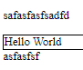

Different HTML elements can point to the same class name.

<h2 class="city">Paris</h2>

<p class="city">Paris is the capital of France</p>

The HTML class attribute is used to specify a class for an HTML element.Multiple HTML elements can share the same class.

The HTML id attribute is used to specify a unique id for an HTML element.You cannot have more than one element with the same id in an HTML document.

<meta charset="UTF-8">

<meta name="description" content="Free Web tutorials">

<meta name="keywords" content="HTML, CSS, JavaScript">

<meta name="author" content="John Doe">

<meta name="viewport" content="width=device-width, initial-scale=1.0">

RESPONSIVE

<h1 style="font-size:10vw">Hello World</h1>

Aspect ratio doesnt change:

<img src="img_girl.jpg" style="width:100%;">

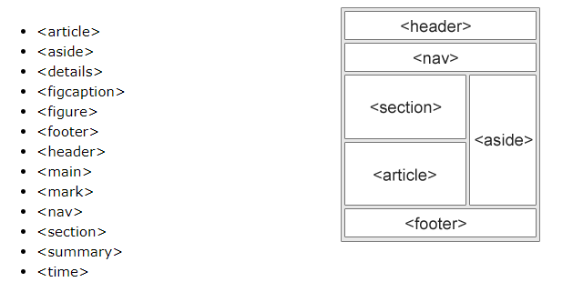

CSS

background-image: url('example_img_girl.jpg');

background-repeat: no-repeat; /*prevents the background image from repeating */

background-size: cover;

/*covers entire background, aspect ratio maintained, some of image cut off */

background-size: 100% 100%;

/*width and height are 100%, aspect ratio lost, image stretched so none is lost*/

background-attachment: fixed;

In this example only <p> elements with class="center" will be red and center-aligned:

p.center {

text-align: center;

color: red;

}

The two below are the same

h1, h2, p {

text-align: center;

color: red;

}

h1 {

text-align: center;

color: red;

}

h2 {

text-align: center;

color: red;

}

p {

text-align: center;

color: red;

}

Use the below to link css

<link rel="stylesheet" href="mystyle.css">

/* This is a single-and multi-line comment */

**Opacity**

<!DOCTYPE html>

<html>

<head>

<style>

body{

background-color: gray;

}

div {

background-color: green;

}

div.first {

opacity: 0.1;

}

div.second {

opacity: 0.3;

}

div.third {

opacity: 0.6;

}

</style>

</head>

<body>

<h1>Transparent Box</h1>

<p>When using the opacity property to add transparency to the background of an element, all of its child elements become transparent as well. This can make the text inside a fully transparent element hard to read:</p>

<div class="first">

<h1>opacity 0.1</h1>

</div>

<div class="second">

<h1>opacity 0.3</h1>

</div>

<div class="third">

<h1>opacity 0.6</h1>

</div>

<div>

<h1>opacity 1 (default)</h1>

</div>

</body>

</html>

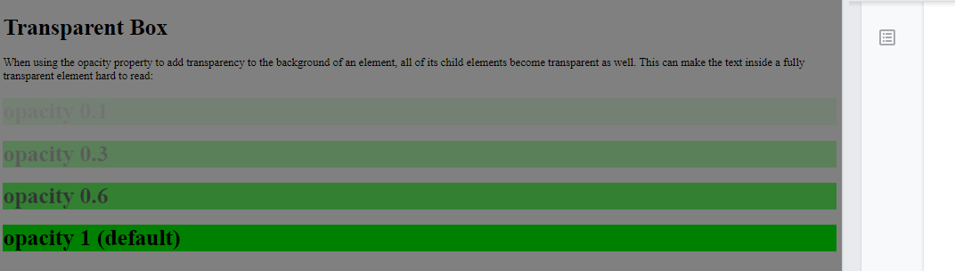

**Background Image**

<!DOCTYPE html>

<html>

<head>

<style>

p {

background-image: url("paper.gif");

}

</style>

</head>

<body>

<h1>Hello World!</h1>

<p>This paragraph has an image as the background!</p>

</body>

</html>

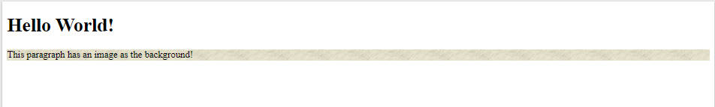

**Background**

body {

background-image: url("img_tree.png");

background-repeat: no-repeat;

background-attachment: fixed; /* can be scroll instead of fix*/

}

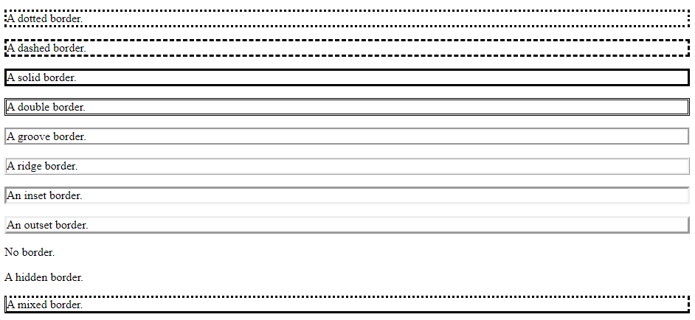

p.one {

border-style: solid;

border-width: 5px;

border-color: red;

border-color: red green blue yellow; /* red top, green right, blue bottom and yellow left */

border-top-style: dotted;

border-right-style: solid;

border-bottom-style: dotted;

border-left-style: solid;

border-radius: 12px; /*creates a rounded border at the vertices*/

}

Margins

margin properties are used to create space around elements, outside of any defined borders.

p {

margin-top: 100px;

margin-bottom: 100px;

margin-right: 150px;

margin-left: 80px;

margin: auto; /*centers element*/

}

Padding

Padding is used to create space around an element's content, inside of any defined borders.

div {

padding-top: 50px;

padding-right: 30px;

padding-bottom: 50px;

padding-left: 80px;

}

The height and width properties do not include padding, borders, or margins. It sets the height/width of the area inside the padding, border, and margin of the element.

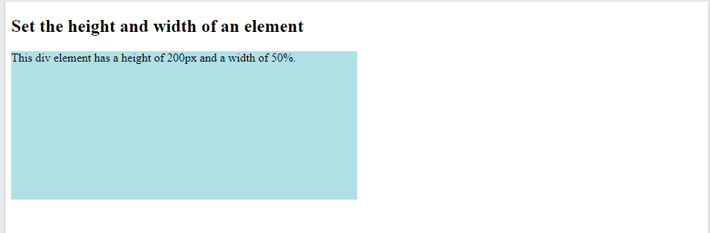

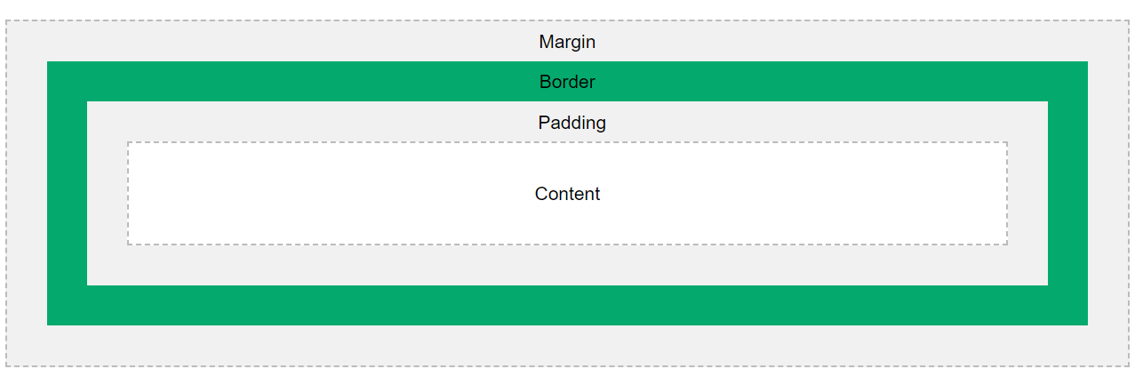

Color

The color property is used to set the color of the text.

The text-align property is used to set the horizontal alignment of a text.

h1 {

background-color: black;

color: green;

text-align: center; /*can also do left or right*/

}

text-align: justify; gives teh following effect

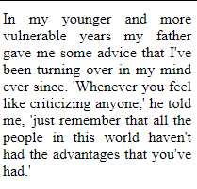

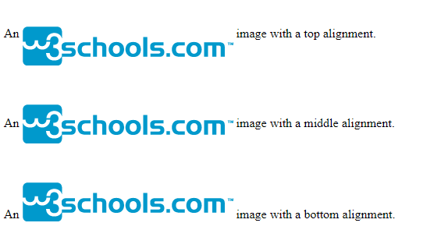

img.top {

vertical-align: top;

}

img.middle {

vertical-align: middle;

}

img.bottom {

vertical-align: bottom;

}

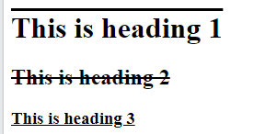

h1 {

text-decoration: overline;

}

h2 {

text-decoration: line-through;

}

h3 {

text-decoration: underline;

}

Removes underline for links

a {

text-decoration: none;

}

Indents the first line

p {

text-indent: 50px;

}

h1 {

letter-spacing: 3px;

}

h2 {

letter-spacing: -3px;

}

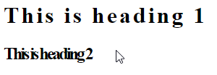

word-spacing: 10px;

p.small {

line-height: 0.7;

}



h1 {

text-shadow: 2px 2px 5px red; /* horizontal shadow, vertical shadow, blur, colour*/

}

Responsive text

<h1 style="font-size:10vw;">Responsive Text</h1>

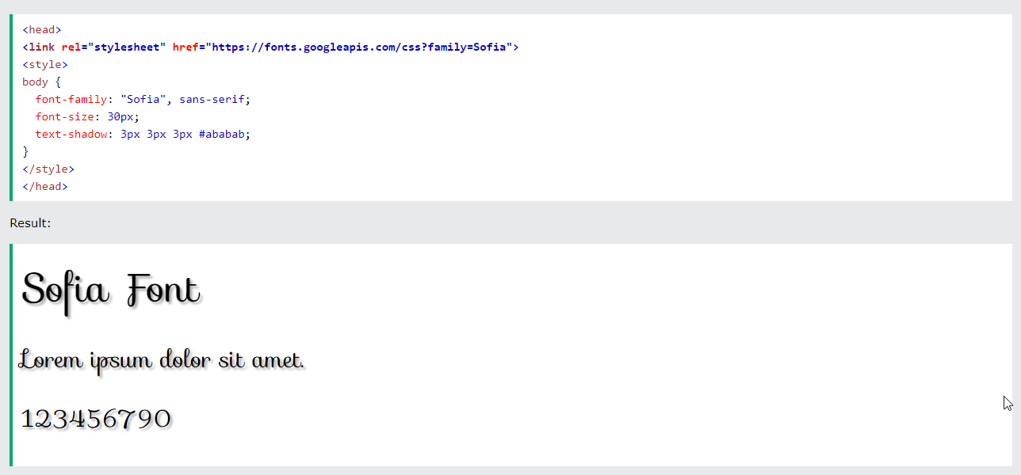

* a:hover MUST come after a:link and a:visited
* a:active MUST come after a:hover

/* unvisited link */

a:link {

color: red;

}

/* visited link */

a:visited {

color: green;

}

/* mouse over link */

a:hover {

color: hotpink;

}

/* selected link */

a:active {

color: blue;

}

<span style="cursor:pointer">pointer</span>

Button link

a:link, a:visited {

background-color: #f44336;

color: white;

padding: 14px 25px;

text-align: center;

text-decoration: none;

display: inline-block;

}

a:hover, a:active {

background-color: red;

}

To create a responsive table, add a container element (like div) with **overflow-x:auto** around the table element:

<div style="overflow-x:auto;">

<table>

<tr>

…

</div>

max-width: 500px;

position: fixed; good for navbar

<https://www.w3schools.com/css/tryit.asp?filename=trycss_navbar_horizontal_responsive>

An element with greater stack order(z-index) is always in front of an element with a lower stack order.

## overflow: auto

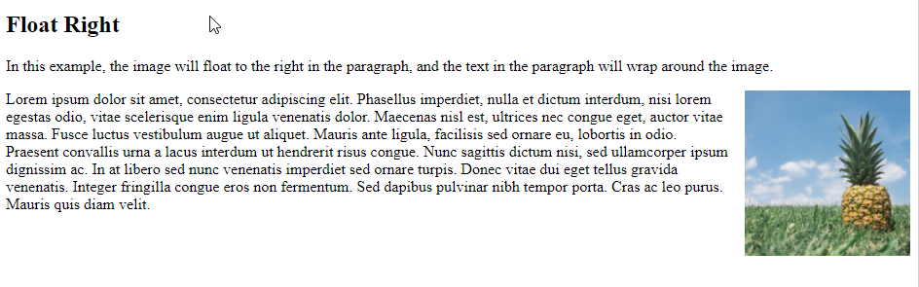

<p><img src="pineapple.jpg" alt="Pineapple" style="width:170px;height:170px;margin-left:15px;">

Lorem ipsum dolor sit amet, consectetur adipiscing elit. Phasellus imperdiet, nulla et dictum interdum, nisi lorem egestas odio, vitae scelerisque enim ligula venenatis dolor. Maecenas nisl est, ultrices nec congue eget, auctor vitae massa. Fusce luctus vestibulum augue ut aliquet. Mauris ante ligula, facilisis sed ornare eu, lobortis in odio. Praesent convallis urna a lacus interdum ut hendrerit risus congue. Nunc sagittis dictum nisi, sed ullamcorper ipsum dignissim ac. In at libero sed nunc venenatis imperdiet sed ornare turpis. Donec vitae dui eget tellus gravida venenatis. Integer fringilla congue eros non fermentum. Sed dapibus pulvinar nibh tempor porta. Cras ac leo purus. Mauris quis diam velit.</p>

img {

float: right;

}

<https://www.w3schools.com/html/html_responsive.asp>